Practice Problems – Chapter 6 Name _____________________

Date ______________

1.



2.

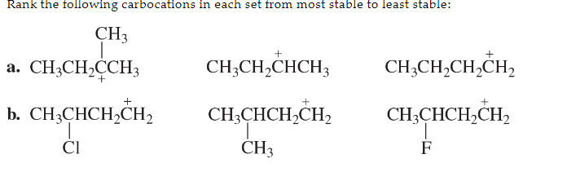  
  
3.  
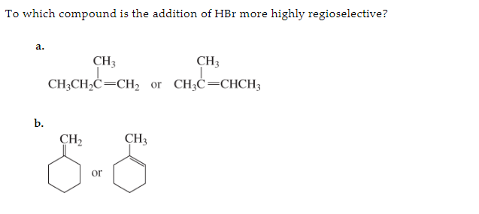

4.  
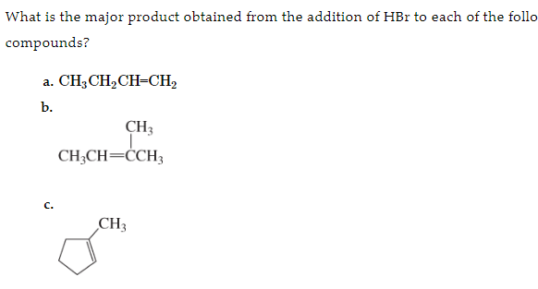

5.   
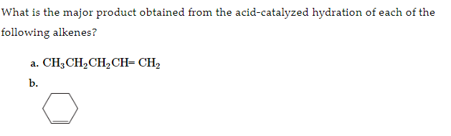

Draw the mechanism for the reaction.

6. Show how each of the following compounds can be synthesized from an alkene.  
